**Description**

**Overview**

This website is created for novice cooks who want to start cooking cheaply but do not know how to go about it, for example, university students. Users can use our website to share recipes and it is very easy to join us here, just click on REGISTER to create an account.

After creating the own account, the user is able to log in and add recipes share them with others, update or delete recipes to do some modification.

On the homepage, users can browse existing recipes on the website, check the recipe details by clicking on the recipe title, or click on a different user name to see what other users have shared. This site also has common functions: change password, change account information and delete account.

**Web pages in a tree**

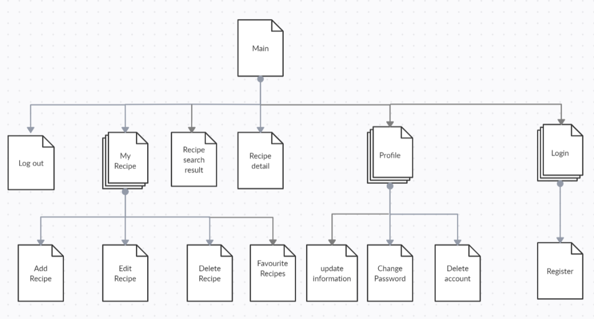

This site’s web pages are presented in the above figure.

For unregistered users, from Homepage users can reach Login page, Register page, About page, User recipe page and Recipe detail page.

For registered users, after logging in, users will go back to homepage, then can reach My recipes page, Profile page, Log out page and New recipe page that are not open to unregistered users. From Recipe detail page, users can reach Edit recipe page, Delete recipe page. From Profile page, users can reach the following pages: Delete account, Change password, and also update their names and email addresses. From Login page, users can sign in, and reach Change password page and Register page.

**Implementation**

This site uses PostgreSQL as the database, python as the backend development language and Django as the web framework, which is a Python-based open-source framework based on the MVC architecture. Many excellent Python packages also are used: Bootstrap4 for designing the pages, Django-crispy-forms for making forms of pages, Whitenoise for managing static files.